WAVE MECHANICAL CONCEPT OF THE ATOM

Dual Nature of Matter

In Bohr atomic model, we see the electron as particle. But in modern wave mechanical concept described by Louis de Broglie in 1924, electron has both wave and particle nature which is known as dual nature of matter.
Louis de Broglie (1892-1987) who was working on his Ph.D. degree at the time, made a daring hypothesis:
“if radiant energy could, under appropriate circumstances behave as though it were a stream of particles, then could matter, under appropriate circumstances, exhibit wave-like properties?”
The dual character- wave and particle may not be confined to radiation alone but extended to matter as well which is called ‘Wave mechanical Theory’.

Hence Bohr concept has been superseded completely by the modern wave mechanical concept.

Heisenberg’s Uncertainty Principle:
For a relatively large solid object, like a bowling ball, we can determine its position and velocity at any given moment with a high degree of accuracy.
However, if an object (like an electron) has wave-like properties then how can we accurately define its' position?
Werner Heisenberg (1901-1976) concluded (in 1927) that due to the dual nature of matter (both particle and wavelike properties) it is impossible to simultaneously know both the position and momentum (mass-velocity) of an object as small as an electron.
- The position and momentum of a moving particle are interdependent and cannot be measured with absolute exactness.
- If momentum is measured accurately, the position becomes less precise; if the position is determined accurately, the momentum becomes uncertain or less accurate.
Thus, it is not appropriate to imagine the electrons as moving in well-defined circular orbits about the nucleus.
Heisenberg’s relationship can be shown as
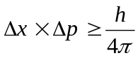
or, 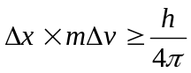
where, = position of a moving particle and 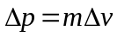 = momentum.

De Broglie’s Equation
According to Planck quantum theory, we know
E = hν --- --- --- (1)
Where E = photon energy, h = Planck constant and ν = frequency of radiation.
From Einstein theory of relativity (mass-energy relationship) we know,
E= mc² --- --- --- (2)
Where m= mass of photon and c = velocity of radiation.
From equation (1) and (2), we get
mc² = hν = h 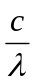 [ν = ]
 mc = 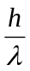 --- (3)
mass × velocity = 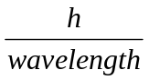
momentum ∝ 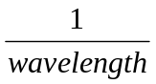
i.e. the momentum of a particle in motion is inversely proportional to wavelength.

This equation is known as de Broglie’s equation.

The de Broglie’s equation is true for all particles, but it is only with very small particles, such as electrons, that the wave-like aspect is of any significance. Large particles in motion though possess wavelength, but it is not measurable or observable. Let us consider de Broglie’s wavelengths associated with two bodies and compare their values.

- For a large mass

A stone of 100g with a velocity of 1000 cm/sec.
λ = 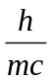 =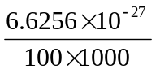= 6.6256 × 10⁻³² cm

This is too small to measure by any instrument and hence no significance.

- For a small mass like atom

Hydrogen atom of 9.109 × 10⁻²⁸g moves with a velocity of 2.188 × 10⁸ cm/sec.
λ = =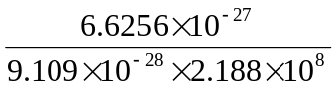= 3.32 × 10⁻⁸ cm

This value is quite comparable to the wavelength of X-rays and hence detectable.

Therefore it is reasonable to expect, everything in nature possess both the properties of particles and waves.

Example-1. Calculate the wavelength of an particle having mass 6.6 × 10⁻²⁷ kg moving with a speed of 10⁵ cm sec⁻¹ (h = 6.6 × 10⁻³⁴ kg m² sec⁻¹.)

Solution:

From de Broglie’s equation, we know λ =

Given, h = 6.6 × 10⁻³⁴ kg m² sec⁻¹
m = 6.6 × 10⁻²⁷ kg
c = 1 × 10⁵ cm sec⁻¹
= 1 × 10³ m sec⁻¹
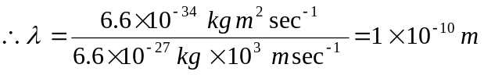 Ans.

Example-2. Calculate the uncertainty in position of an electron if the uncertainty in velocity is 5.7 × 10⁵ msec⁻¹.

Solution: According to Heisenberg’s uncertainty principle,
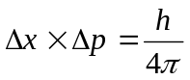 or, 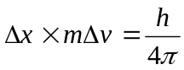 or, 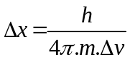
Here, Δv = 5.7 × 10⁵ msec⁻¹, h = 6.6 × 10⁻³⁴ kg m² sec⁻¹ and m = 9.1 × 10⁻³¹ kg

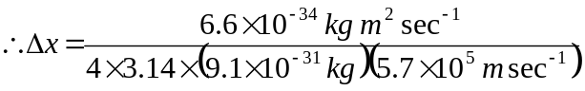

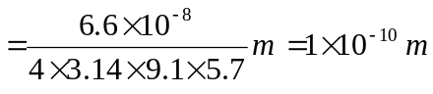 Ans.

Schrödinger’s Wave Equation:

To calculate the probability of finding the electron at various points in an atom, Schrödinger in 1926 derived an equation. This is called the Schrödinger’s wave equation.

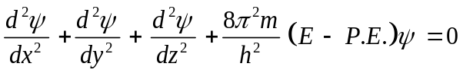

where, = wave motion, x, y & z = distance from nucleus considering three axis, = wavelength and A = constant (maximum value of).

Probability Distribution Curves:

The wave equation for a given electron gives a three-dimensional arrangement of points where it can possibly lie. There are regions where the chances of finding the electron are relatively greater. Such regions are called ‘cloud of negative charge’.

The three-dimensional region within which there is higher probability that an electron having certain energy will be found, is called an ‘orbital’.

An orbital is the most probable space in which the electron spends most of its time while in constant motion. In other words, it is the spatial description of the motion of an electron corresponding to a particular energy level. The energy of electron in an atomic orbital is always the same.

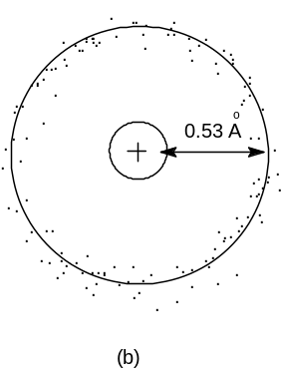
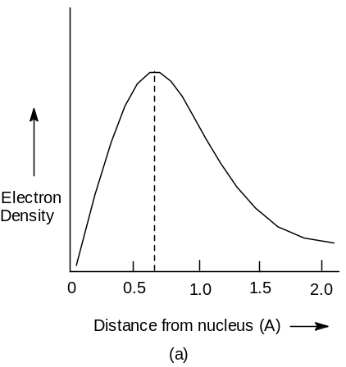

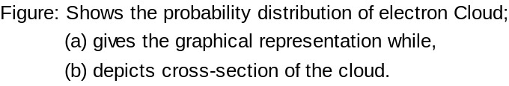

QUANTUM NUMBERS (Q.N.)

The quantum numbers of an electron that gives information about its size and shape of energy level, orientation and spin around the nucleus are-

- Principal Quantum Number, n: The main shell (or level) to which the electron belongs (size). This number has a dependence only on the distance between the electron and the nucleus. The average distance increases with n, and hence quantum states with different principal quantum numbers are said to belong to different shells.
Principal quantum number (n=) 1 2 3 4
Letter designation K L M N
Maximum number of electrons (2n²=) 2 8 18 32

- Azimuthal (subsidiary) Quantum Number, l: The sub-shell which governs the angular momentum of the electron. In chemistry, this quantum number is very important, since it defines the shape of an atomic orbital occupied by the electron and strongly influences chemical bonds and bond angles. For any given value of the principal quantum number ‘n’, the azimuthal quantum number ‘l’ may have all integral values from 0 to n-l.
n=1 n=2 n=3 n=4
l=0 (1s) l=0 (2s) l=0 (3s) l=0 (4s)
l=1 (2p) l=1 (3p) l=1 (4p)
l=2 (3d) l=2 (4d)
l=3 (4f)

Principal  Q-number,  n |  | Azimuthal  Q-number,  l (0 to n-1) |  | Magnetic Q-number,  m (-l to +l) | Spin Q-number,  S (+½, -½) | Number of electrons accommodated(2n²)
1 | K | 0 | s | 0 | 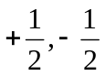 for each value of m | 2 | 2
2 | L | 0 | s | 0 | for each value of m | 2 | 8
 |  | 1 | p | +1, 0, -1 | for each value of m | 6 | 8
3 | M | 0 | s | 0 | for each value of m | 2 | 18
 |  | 1 | p | +1, 0, -1 | for each value of m | 6 | 18
 |  | 2 | d | +2, +1, 0, -1, -2 | for each value of m | 10 | 18
4 | N | 0 | s | 0 | for each value of m | 2 | 32
 |  | 1 | p | +1, 0, -1 | for each value of m | 6 | 32
 |  | 2 | d | +2, +1, 0, -1, -2 | for each value of m | 10 | 32
 |  | 3 | f | +3, +2, +1, 0, -1, -2, -3 | for each value of m | 14 | 32

- Magnetic Quantum Number, m: This governs the energies of electrons in an external magnetic field and gives orientation. This is the projection of the orbital angular momentum along a specified axis. For any given value of the azimuthal quantum number ‘l’, the magnetic quantum number ‘m’ may assume all the integral values from +l to -l through zero i.e. +l, (+l-1), …0, …(-l+1), -l. Therefore for each value of ‘l’ there will be (2l+1) values of ‘m’.

- Spin Quantum Number, s: This quantum number has been introduced to account for the spin of electrons about their axis. Since an electron can spin clockwise or anticlockwise, there are two possible values of ‘s’ that are equal and opposite, +½ and -½ along the specified axis for each value of ‘m’. Since a spinning charge is associated with a magnetic field, an electron must have a magnetic moment associated with it.

ORBITALS

An atomic orbital is a mathematical function that describes the wave-like behavior of either one electron or a pair of electrons in an atom. This function can be used to calculate the probability of finding any electron of an atom in any specific region or shell around the atom's nucleus. Each shell is subdivided into subshells, which are made up of orbitals, each of which has electrons with different angular momentum. Each orbital in a shell has a characteristic shape, and is named by a letter. They are: s, p, d, and f. In a one-electron atom (e.g. H, He⁺, Li⁺, etc.) the energy of each orbital within a particular shell is identical. However, when there are multiple electrons, they interact and split the orbitals into slightly different energies. Within any particular shell, the energy of the orbitals depend on the angular momentum of orbitals s, p, d, and f in order of lowest to highest energy. No two orbitals have the same energy level.

Orbitals having same energy are known as degenerate orbitals. Since the number of p-orbitals having the same energy is three, these orbitals are said to be three-fold degenerate orbitals. Since the number of d-orbitals having the same energy is five, these orbitals are said to be five-fold degenerate orbitals.

Node and nodal plane: The nucleus at which the electron density is zero is called node and the plane passing through the orbital-axis is called nodal plane. At this plane the electron density is also zero.

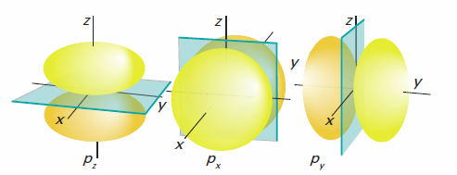
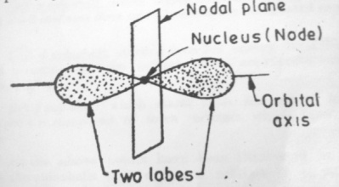

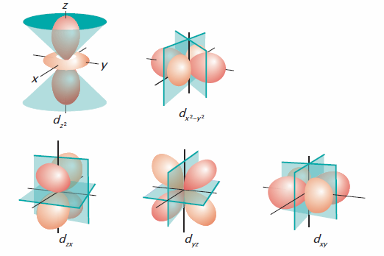

Figure: Node and nodal plane of p and d-orbitals.

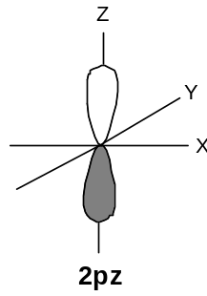
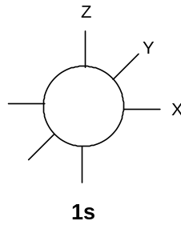
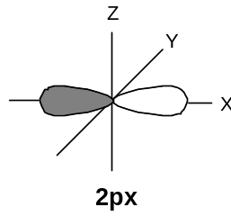
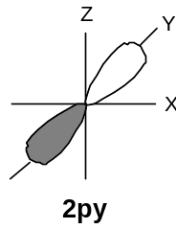

Figure: Shapes and orientations of s & p-orbitals

s- orbitals: spherical shaped

p- orbitals: p-orbitals are dumb-bell shaped consisting of two lobes along axis.

d- orbitals: d-orbitals are complex geometrical shapes as compared to p-orbitals, lobes lie in the plane, along axis.

There are five different d-orbitals on the basis of the orientation of their lobes of maximum electron density with respect to x, y and z axes. They are designated as dxy (l = 2, m = -2), dyz (l = 2, m = -1), dzx (l = 2, m = +1), dx²-y² (l = 2, m = +2) and dz² (l = 2, m = 0).

All these five d-orbitals are not identical in shape. Four out of five d-orbitals namely dxy, dyz, dzx (lobes lie in the plane) and dx²-y² (lobes lie along axis) for a given energy level contain four lobes (double dumb-bell shaped) and the fifth orbital, dz² consists of only two lobes lie along z-axis (dumb-bell shaped).

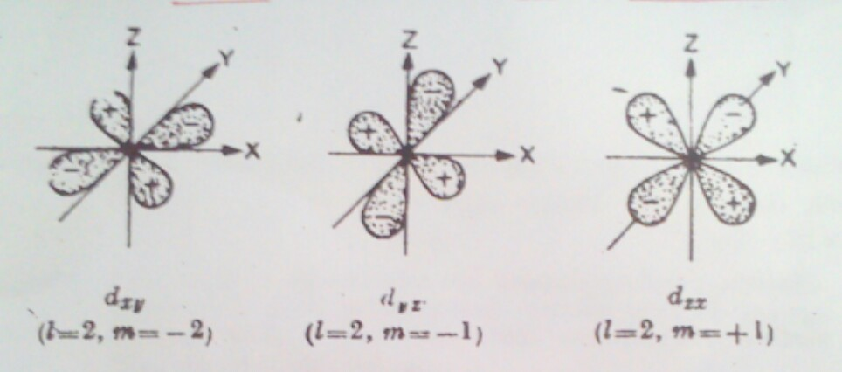

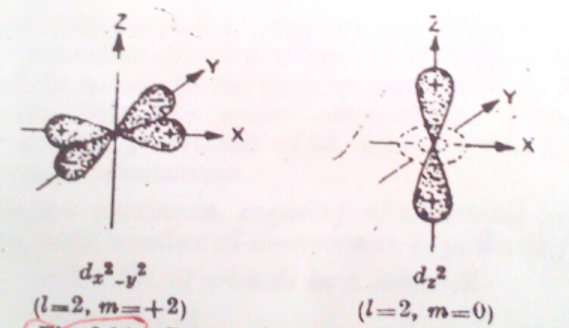

Figure: Shapes and orientations of d-orbitals

Electronic Configuration of Atoms follows the three principles:

- Pauli’s Exclusion Principle: The four quantum numbers of two electrons of an atom will never be same. e.g. He (2)
(e₁) n = 1, l = 0, m = 0, s = +½
(e₂) n = 1, l = 0, m = 0, s = -½
i. e. spin is different.

- Aufbau Principle: Electron occupy first lower energy orbits and then successively to higher level orbits. Because lower energy levels are more stable.

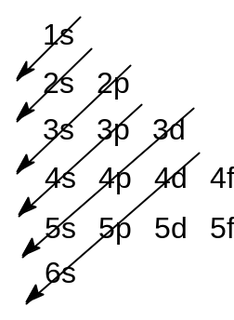
1s, 2s, 2p, 3s, 3p, 4s, 3d, 4p, 5s, 4d, 5p, 6s etc.

The energy of an orbital is determined by sum of n and l. This is called (n+l) rule.For example, let us compare the (n+l) value for 3d and 4s orbitals. For 3d orbital n=3, l=2 and n+l=5 and for 4s orbital n=4, l=0 and n+l=4.

- Hund’s Rule: In different orbits of same energy, electrons are so arranged that they can exist as maximum single electrons.

N (7) - 1s²2s²2p_{x}¹2p_{y}¹2p_{z}¹

Some exceptions:

Cu (29) – 1s²2s²2p⁶3s²3p⁶3d⁹4s² will be 3d¹⁰4s¹
Cr (24) - 1s²2s²2p⁶3s²3p⁶3d⁴4s² will be 3d⁵4s¹

Because for a more stable configuration half-filled and full-filled orbitals are preferred.

----------------------------------------------------------------------------------------------------------------
Problem-10. What is the wavelength associated with a particle of mass 0.1g moving with a speed of 1 × 10⁵ cm sec⁻¹. (h =6.6×10⁻²⁷ erg sec).

Problem-11. The uncertainty in the position of a moving bullet of mass 0.01 kg is 1.0×10⁻⁵ m; calculate the uncertainty in its velocity. (Answer. 5 ×10⁻²⁸ msec⁻¹)

Problem-12. What is the mass of a photon of sodium light with a wavelength of 5890 Ǻ? (Hints: λ=h/mv; h =6.6×10⁻²⁷ erg sec, λ=5890×10⁻⁸cm, v= 3×10¹⁰cm/sec; Ans. 3.76 ×10⁻³³ g)

Problem-13. The uncertainty in the position and velocity of a particle are 10⁻¹⁰ m and 5.27 × 10⁻²⁴ m sec⁻¹ respectively. Calculate the mass of the particle. (Given Planck’s constant, h = 6.6×10⁻³⁴ kg m² sec⁻¹).

Problem-14. The velocity of a ball being bowled by Mohammad Rafiq is 25 m sec⁻¹. Calculate the wavelength of the matter-wave associated with the ball. (Weight of the ball = 158.5 g; h = 6.625 × 10⁻²⁷ erg sec).

Problem-15. (a) An electron is in 4f orbital. What possible values for the quantum numbers n, l, m and s can it have? (b) What designation is given to an orbital having (i) n=2, l=1 and (ii) n=4, l=0?

Problem-16. A neutral atom has 2K, 8L, 5M electrons. Find out the following from the data (a) atomic number, (b) total number of s electrons, (c) total number of p electrons, (d) number of protons in the nucleus, and (e) valency of elements.

Problem-17. State which of the following sets of quantum numbers would be possible and which would be impossible for an electron in an atom.
(a) n=0, l= 0, m= 0, s= +½ [Impossible]; (b) n=1, l= 1, m= 0, s= +½ [Impossible]
(c) n=1, l= 0, m= 0, s= -½ [Possible]; (d) n=2, l= 1, m= -2, s= +½ [Impossible]
(e) n=2, l= 1, m= -1, s= +½ [Possible]

Problem 18. (a) How many electrons are there in hydrogen and chlorine atom (atomic number 17)? How they are arranged? What is the valency of hydrogen and chlorine in HCl? (b) The atomic number of Na and Cl are 11 and 17 respectively. Determine the number of electrons in Na⁺ and Cl⁻.

